Numbers to English Word Representation Django REST Framework API

Two RESTful endpoints are exposed to the user to convert a given number to is English word representation.

There are two Django REST Framework APIs created that will return the English Word representation of a number in a JSON HTTP Response

This is a Django project and can be launched by navigating to the project directory where the manage.py is located an executing the “python manage.py runserver” command.

Once the webserver is running, the API can be used as shown in the following examples.

Example 1) Open a browser and go to 127.0.0.1:8000/num_to_english/9895389492899

This is the result of doing a GET /num_to_english

{

“number”: “9989538949238”

}

Output

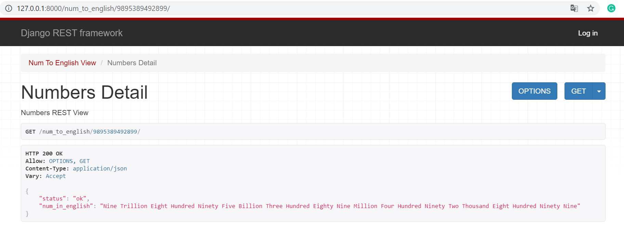

Example 1) Django REST Framework API JSON Output

Example 2) Open a browser and go to 127.0.0.1:8000/num_to_english/?number=9868976978

This is the result of doing a GET /num_to_english

{

“number”: “9989538949238”

}

Output



Ex. 2) Django Numbers to English REST JSON API

Given Case 1)

Input

GET /num_to_english/12345678

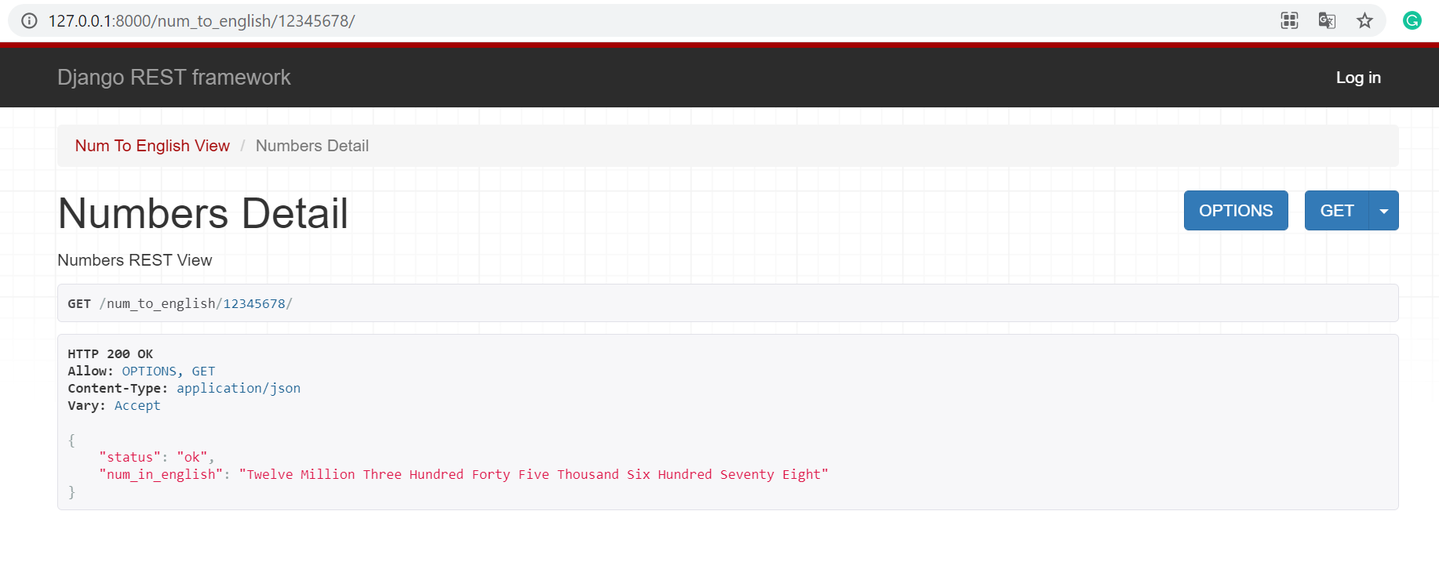

Given Case 2)

Input

GET /num_to_english/?number=12345678

Output

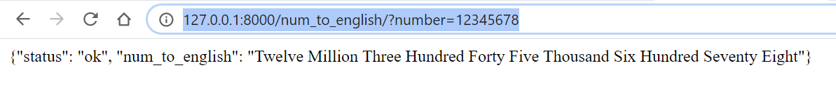

Code Layout with Django REST Framework

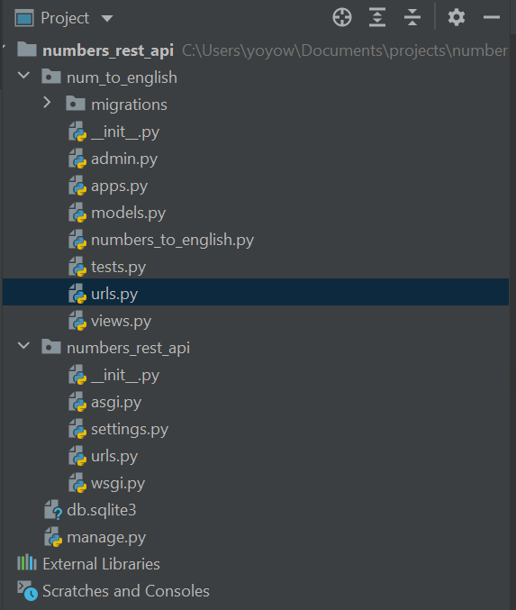

Layout

Views

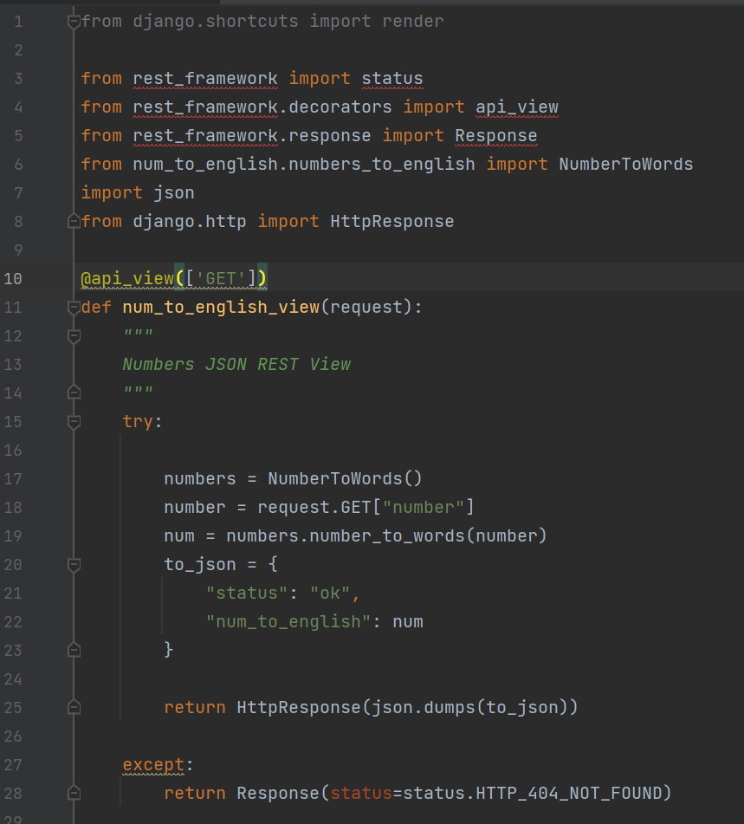

Views 2

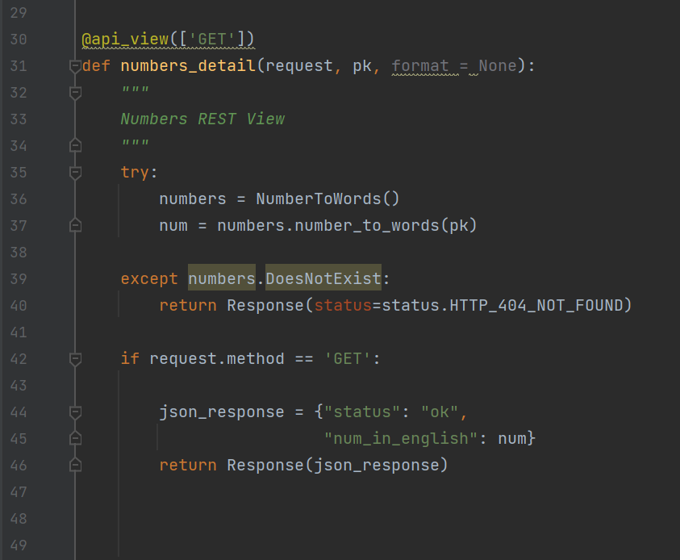

Urls

App Urls

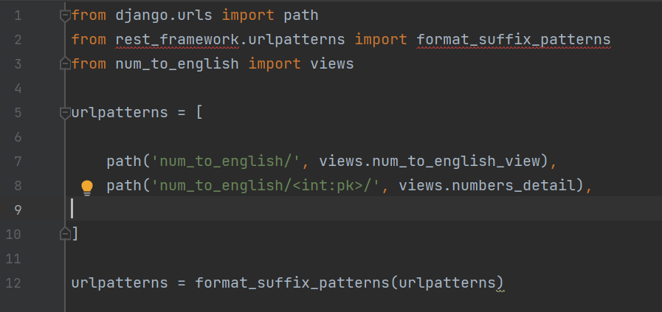

Project Urls

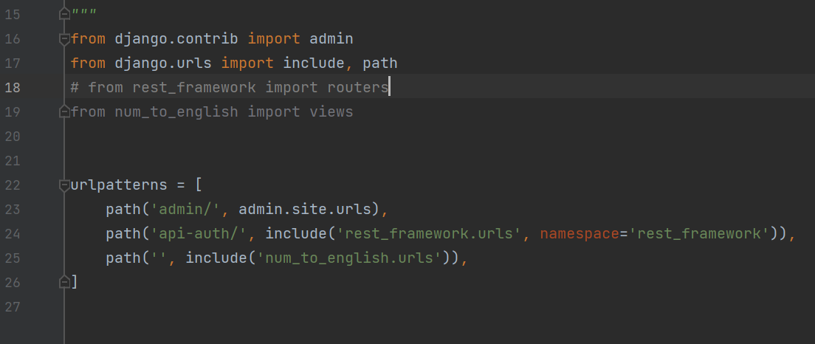

Numbers to English

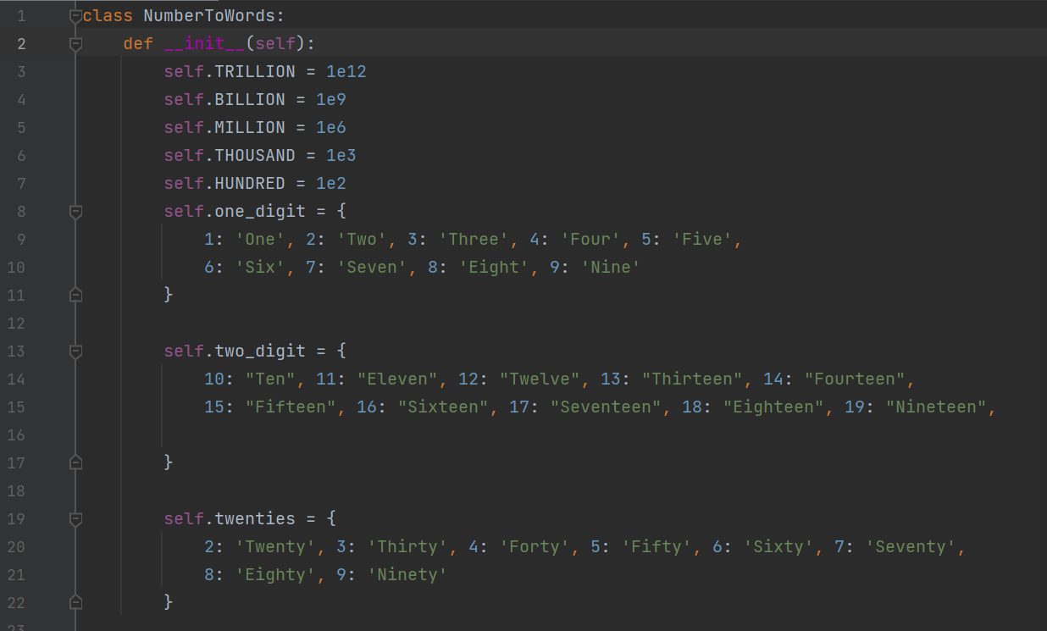

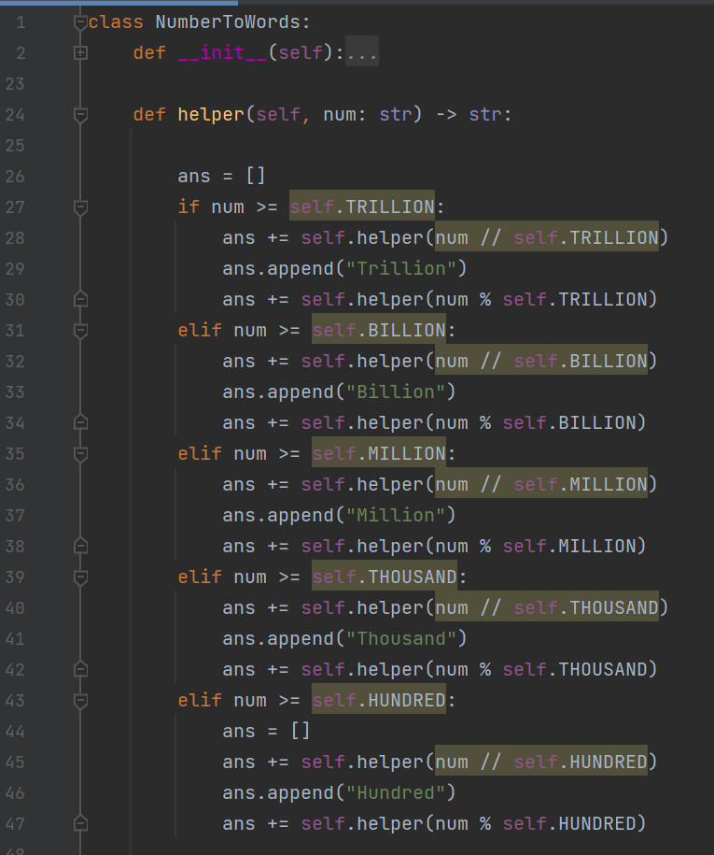

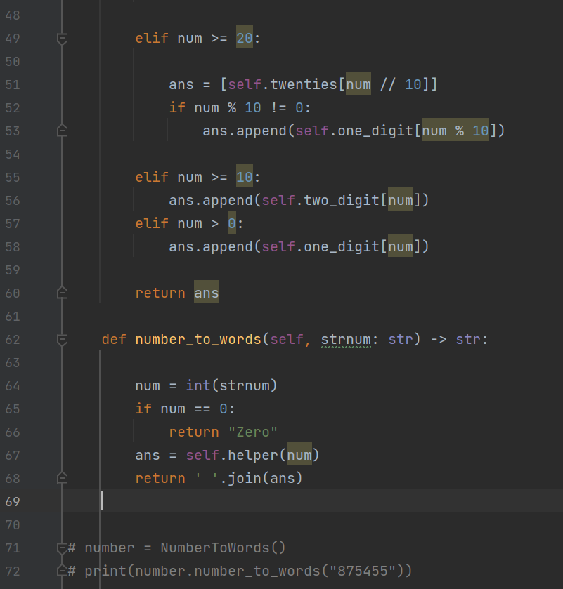

Settings - Apps

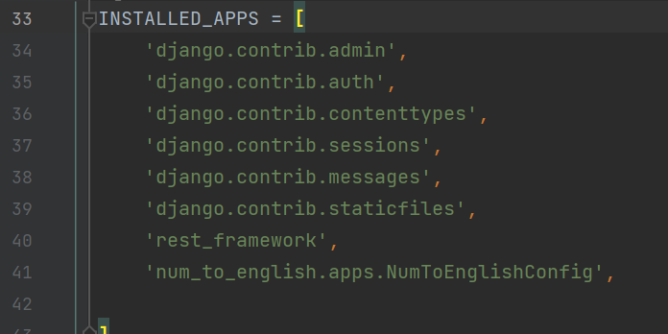

Error Cases Return 404 Error Codes

Root Error

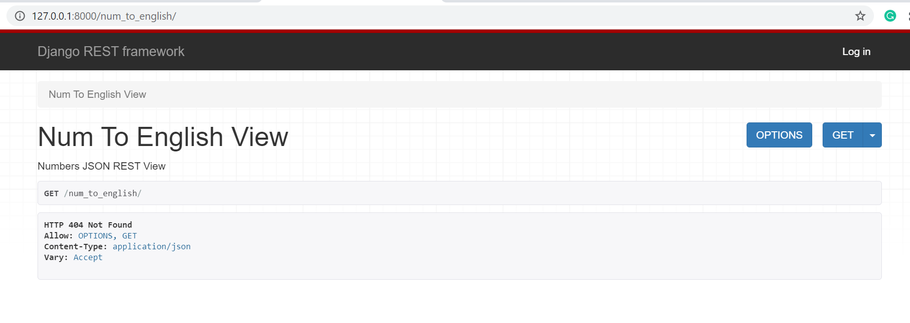

JSON Error

